Hotel Booking Service Guarantee of Convergent Travel
- Introduction 内容
- Convergent hereby promises that the hotel information and prices provided by the Company are true and the room status is accurate. Convergent shall provide 7*24h whole-process guarantee services for the orders upon the booking order confirmation of all the partners (online, text message, fax and email), to keep you free of worries. Please make bookings at ease. In case of the confirmation of room unavailability, we will strictly execute the after-sale guarantee program. Our commitments are as follows:
汇智承诺我司所提供的酒店信息、价格真实、房态准确。汇智对于所有合作伙伴预定订单一经确认（在线、短信、传真、邮件），将对订单提供7*24小时全程保障服务，免去您的后顾之忧，请放心预定。如遇到确认无房情况，将严格执行售后保障计划，承诺如下：
- In case of no room available after confirmation by Convergent (before the customer arrives for check-in), please handle it according to the following steps:
汇智确认后无房（客人未到店）按照以下步骤依次处理：
- In case the room of original order in the hotel is unavailable, Convergent shall arrange check-in service for the upgraded room in the original hotel free of charge and Party A shall bear the price difference thereby incurred (no more than the room charge for the first night).
原预订酒店订单中的房型满房提供免费升级原标准以上级别的房间入住，由此产生的差价（最高不超过订单首晚房费）由甲方承担。
- In case that all rooms in the original hotel are unavailable, Convergent shall arrange the check-in for your guests in the equivalent room type or above in other hotels in a standard no lower than the original hotel, and Party A shall bear all the price difference thereby incurred (no more than the room charge for the first night).
如原预订酒店房型全满，汇智推荐乙方客人入住附近不低于原标准的其他酒店同等或以上房型，由此产生的差价（最高不超过订单首晚房费）由甲方承担。
- In case that all rooms in the original hotel are unavailable, Party A shall bear the price difference (no more than the room charge at the first night) if guests notify Party A before changing to book rooms in equivalent type or above in the original hotel by themselves. If guests do not book rooms through the company, they shall provide proof of invoice of hotel for price difference (no more than room charge for the first night).
如原预订酒店房型全满，客人自行改订原酒店同级或更高房型入住前告知甲方，其产生的差价（最高不超过订单首晚房费）由甲方承担，如未经我司预订，产生的差价（最高不超过订单首晚房费）需提供酒店发票凭证。
- In case the hotel fails to arrange other hotels or the recommended hotel is rejected, the original order shall be cancelled, and Party A shall refund the cost for original order to Party B, and pay the compensation. In case Party B is informed of no room available after confirmation by Convergent before 14:00 p.m. (Beijing time) on the day before the actual check-in date, Party A shall pay the compensation up to 30% of the room charge for the first night of Party B’s original order. In case Party B is informed after 14:00 p.m. (Beijing time) on the day before the actual check-in date, Party A shall pay the compensation up to room charge for the first night of Party B’s original order.
若无法安排其他酒店或推荐酒店乙方不接受，原订单取消，退还乙方原单费用，甲方启动赔付。如果甲方在乙方入住日期前一天14：00（北京时间）之前通知乙方无房，则甲方向乙方赔付该订单首晚房费的30%；如果甲方在乙方客人入住日期前一天14：00之后通知乙方无房，则甲方向乙方赔付该订单首晚房费。
- Service Procedures 服务流程
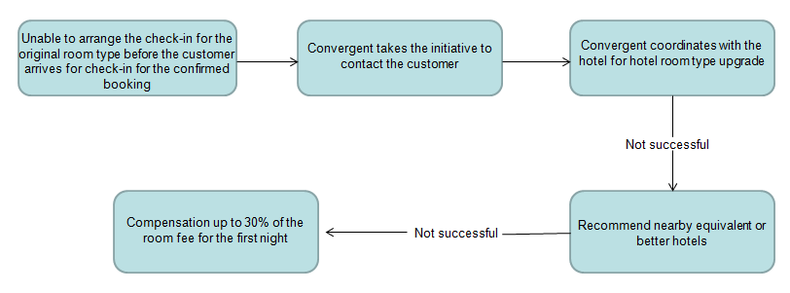

- In case Convergent fails to arrange check-in after the order is confirmed (the guest has arrived for check-in), please handle it according to the following steps:
汇智确认后无房（客人已到店）按照以下步骤依次处理：
- In case that the room of original order is unavailable, Convergent shall provide check-in service for the upgraded room in the original hotel, and Party A shall bear the price difference thereby incurred (no more than room charge for the first night).
原预订酒店订单中的房型满房提供原酒店原标准以上级别的房间入住，由此产生的差距（最高不超过订单首晚房费）由甲方承担。
- In case that the room of original order is unavailable, Convergent shall arrange check-in for guests in the equivalent standard or above in other hotels at the standard no lower than the original hotel, and Party A shall bear all the transportation fee (no more than RMB100) and price difference (no more than room charge for the first night).
如原预订酒店房型全满，汇智推荐乙方客人入住附近不低于原标准的其他酒店同等或以上房型，由此带来的交通费（不高于100元）及房价差价（最高不超过订单首晚房费）由甲方承担。
- In case that all rooms in the original hotel are unavailable, Party A shall bear the price difference (no more than the room charge at the first night) if guests notify Party A before changing to book rooms in equivalent type or above in of the original hotel by themselves. If guests do not book rooms through the company, they shall provide proof of invoice of hotel for price difference (no more than room charge for the first night).
如原预订酒店房型全满，客人自行改订原酒店同级或更高房型入住前告知甲方，其产生的差价（最高不超过订单首晚房费）由甲方承担，如未经我司预订，产生的差价（最高不超过订单首晚房费）需提供酒店发票凭证。
- In case the hotel fails to arrange other hotels or the recommended hotel is rejected, the original order shall be cancelled, and Party A shall refund the cost for original order to Party B, and pay the compensation up to the room charge for the first night of Party B.
若无法安排其他酒店或推荐酒店乙方不接受，原订单取消，退还乙方原单费用，甲方启动赔付，赔付标准最高为乙方原订单首晚房费。
- In case that the Convergent receives complaint from Party B about unavailability of room upon arrival, it shall handle it within 20 minutes. If the order fails to be handled well within 20 minutes, Party B shall be entitled to notify Party A compensation or wait for room rearrangement.
汇智在接到乙方投诉到店无房均有20分钟的处理时间，如订单处理超过20分钟处理无果，乙方有权通知甲方选择走赔付流程或者继续等待调房。
- Service Procedures: 服务流程
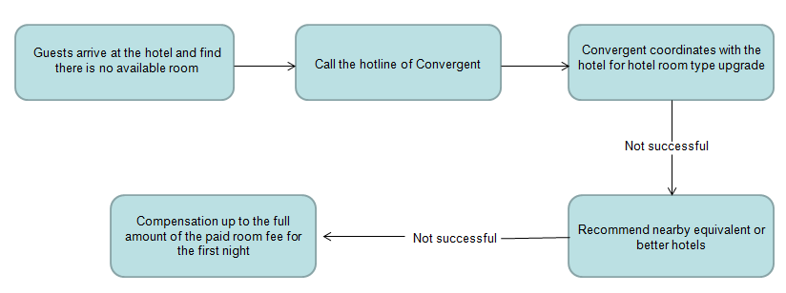

Notes:注意事项
- If you fail to contact Convergent for confirmation in time and take other measures on your own when the room of confirmed order is unavailable, then it shall be deemed as waiver of the right of service guarantee.
已确认订单如出现无法安排入住等情况未及时联系深圳捷旅确认而自行采取其他措施的，视为您放弃了服务保障权利。
- Situations not applicable to the compensation of service guarantee: 不符合赔付服务保障范畴的几种情况：
  - Convergent has not confirmed the changes including arrival date and room type.
入住日期、房型等事项变更，未经过汇智确认。
  - The customer rejects the room in the original hotel at the standard no lower than the original provided by Convergent or the hotel.
汇智或酒店已提供不低于原标准的原酒店房间，客户不接受。
  - The failure of hotel check-in is caused by uncontrollable factors (e.g. natural disaster, emergency, government expropriation, hotel test sheet, etc.) (Convergent may provide proof);
因不可控因素（例如：自然灾害、突发事件、政府征用、酒店测试单等）而造成的酒店无法入住（汇智可提供证明）。
  - The check-in is not for actual stay, or genuine and valid certificates for check-in are not provided, or the information of the certificates including the person, city and date is inconsistent with the order;
未实际入住或者未提供真实有效入住凭证,或入住凭证中入住人、城市、日期等信息与原订单不符。
  - The advance order is not successfully paid for before the payment deadline;
预付订单，已过最晚付款时限未成功支付的。
  - The hotel has clearly stipulated the restriction of the channel but the channel source of the order is still inconsistent (e.g. Ctrip, etc.);
酒店或汇智已明确规定渠道限制，仍存在渠道来源不符的订单（例如：携程等）
- In case the compensation application is verified and confirmed by Convergent and the partner, no other compensation change for any reason shall be accepted;
对于汇智与合作伙伴已核实确认的赔付申请，不再接受其他任何理由的赔付变更。
- All the compensation amounts of Convergent shall not exceed the corresponding compensation standards. 汇智所有赔偿赔付金额不超过对应赔偿标准。
- Convergent reserves all the right for the final interpretation of all terms.
汇智所有赔偿赔付金额不超过对应赔偿标准。

